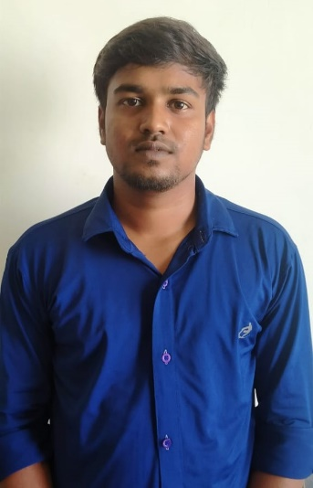

**EDUCATION**

**Bachelor Of Engineering(ECE) --> 2018-2022Batch**

Government College Of Engineering Dharmapuri

**CGPA -- 8.0%**

**Class 12 --> 2017-2018Batch**

Government Higher Secondary school Chinnappampatty

**PERCENTAGE -- 86%**

**CGPA -- 8.0%**

**SOCIAL DISTANCING DETECTION USING OPENCV AND DEEP LEARING**

Using MATLAB,Machine Learing & Webcam.

**Class 10 --> 2015-2016Batch**

Government Higher Secondary school Chinnappampatty

**PERCENTAGE -- 87%**

**CGPA -- 8.0%**

**ACADEMIC PROJECT**

To be an efficient Software professional in an organization and looking forward to an opportunity where I can utilize my professional skills that offer professional growth while being innovative and resourceful.



**HOBBIES**

**TAMIL - ⏹ - ⏹ - ⏹ - ⏹ - ⏹**

**ENGLISH- ⏹ - ⏹ - ⏹ - ⏹ - ⏹**

**LANGUAGES**

**NodeJs,MongoDB**

**⏹ - ⏹ - ⏹ - ⏹ - ⏹**

**HTML,CSS**

**⏹ - ⏹ - ⏹ - ⏹ - ⏹**

**JavaScript,ReactJs**

**⏹ - ⏹ - ⏹ - ⏹ - ⏹**

**SKILLS**

Salem in TamilNadu

Salem



91+ 6380535912



jayaprakash58563@gmail.com



**CONTACT**

JAYAPRAKASH G G